**Assignment -1**

**Bash Scripting Task**

**1.**sample execution of Bash script

* Created one instance in aws and launched

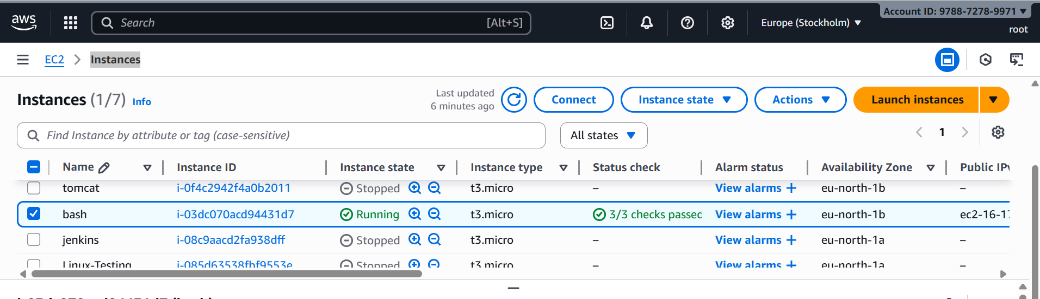

* Connect to aws ec2 by using **ssh –I bash-script** [**ec2-user@16.171.136.104**](mailto:ec2-user@16.171.136.104)

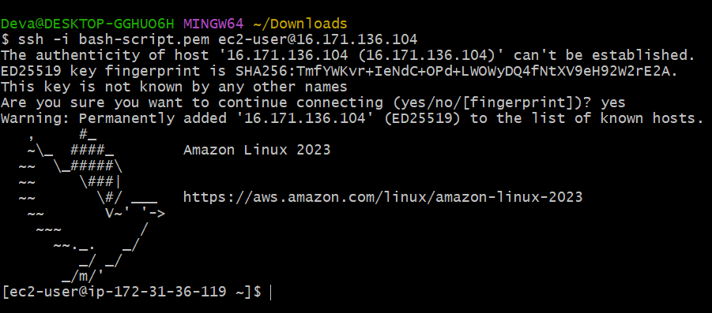

* Create the file **test** and inserted some commands to be executed

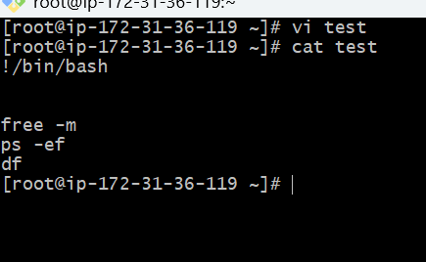

* Give the execute permissions to the file **chmod 777 test**
* **ll** - it shows the long list

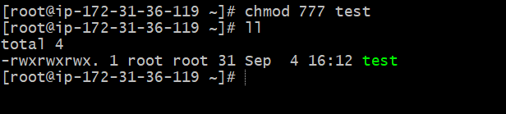

* ./test - We have to automated our manual process

Echo $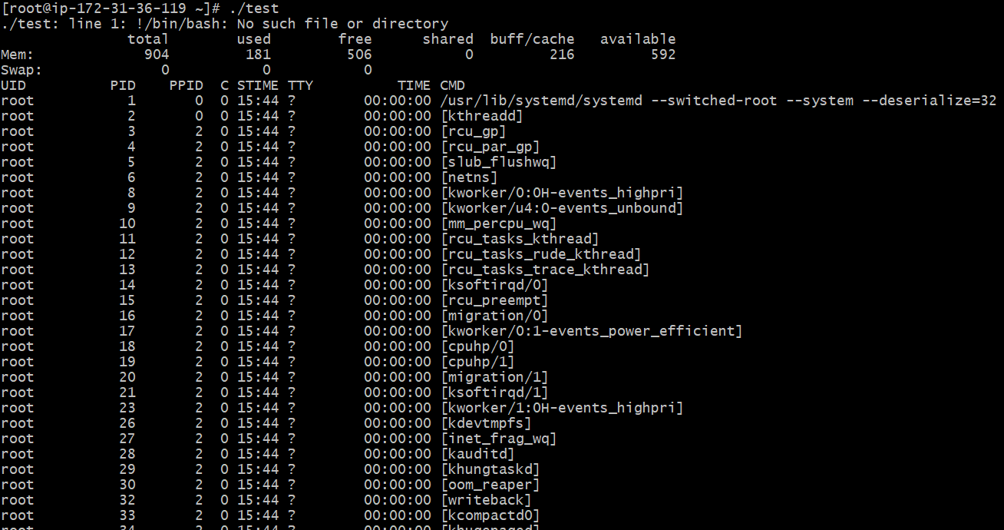

* **Echo $0** - It shows the current shell like which shell we are using

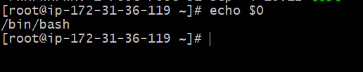

* **Cat /etc/shells -** it shows different shells in our linux server (Available shells)

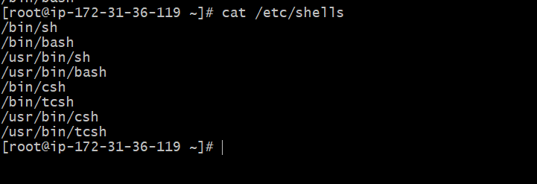

* **Cat /etc/passwd**  - to know which shell user is assigned with

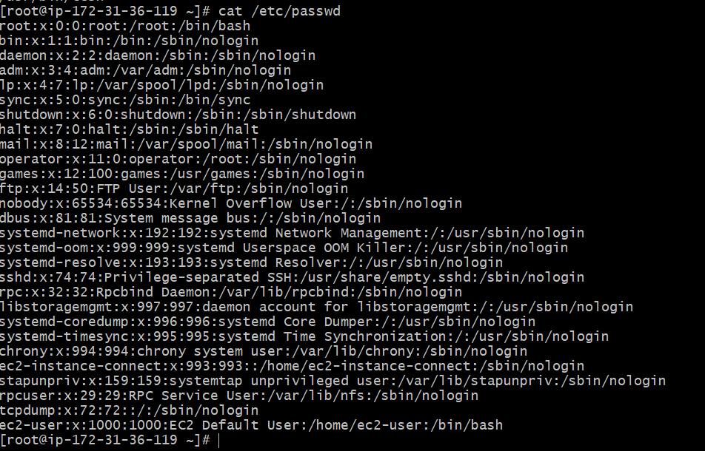

* If you want to switch any particular shell , instead of using bash shell , I want to use shell **sh** – shell , **csh , tcsh**
* **echo $0** - It shows which shell you are using

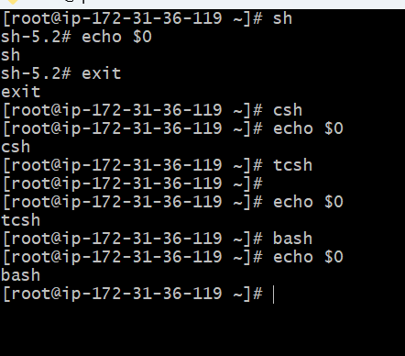

* check present working directory – **pwd**
* created one firectory - **mkdir –p /Devendra/scripts**
* **ls** – list of files
* **pwd** - present working directory

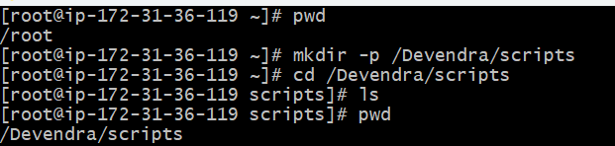

* **vi hello world** - created one script called hello world



* write some content and save **:wq!**

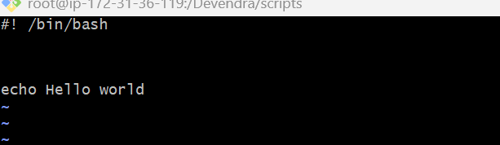

* **chmod 777 hello world** - change the permissions
* if you want to execute - **./hello world**
* **pwd -** present working directory
* **ll -** long list
* **/Devendra/scripts/hello world -** it shows output
* **Cd /Devendra/scripts/ -** to change the directory

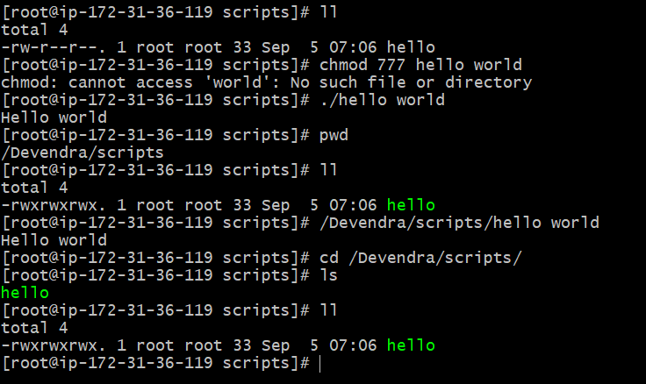

* **./hello world** and **bash hello world -** with these we can execute our scripts

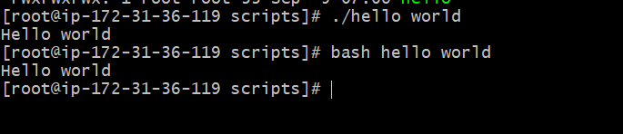

* Created one script file **vi abc.bash**
* **ll -** long list
* **./abc.bash -**  it will check for the permissions (permission denied)

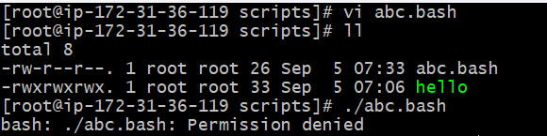

* **bash abc.bash -** it will not check for permissions

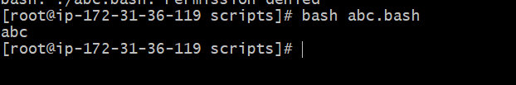

* give permissions to file and check - **chmod 755 abc.bash**

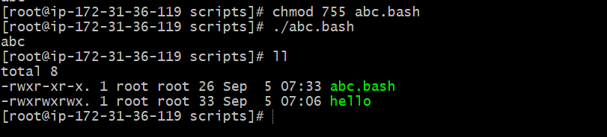

* create a scripted file **vi helloworld.bash**
* **ls -** listed files
* **ll –** long list
* **chmod 777 helloworld.bash -** given full access to that file

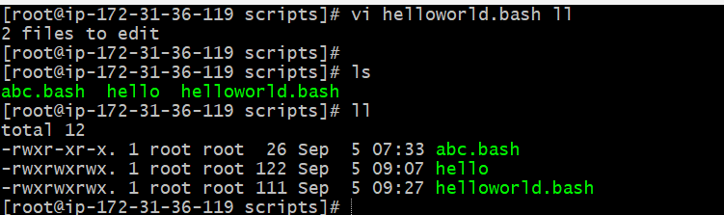

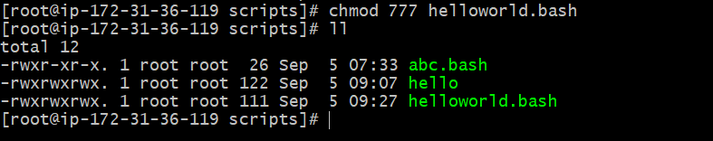

* entered that file and write content and save **:wq!**

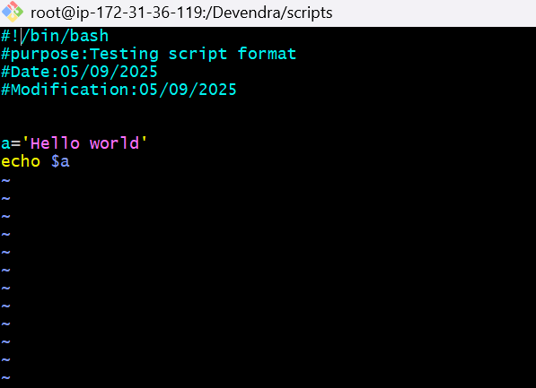

* **cat helloworld.bash** - Read the contents of file

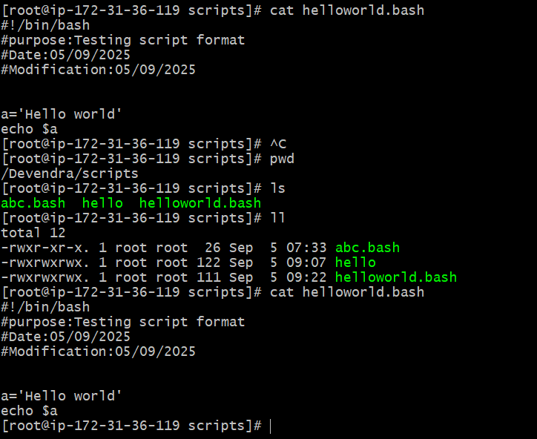

* **./helloworld.bash** - execute the scripts

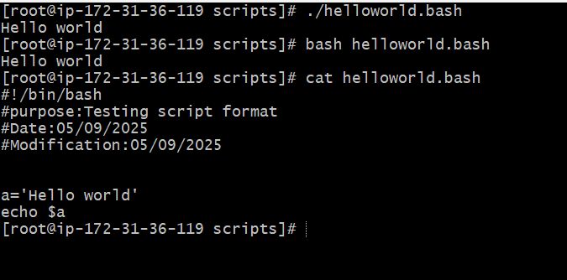

* **Sequence script:-**
* Script will execute from top to bottom
* **vi hello world.bash -** created a scripted file and write some content

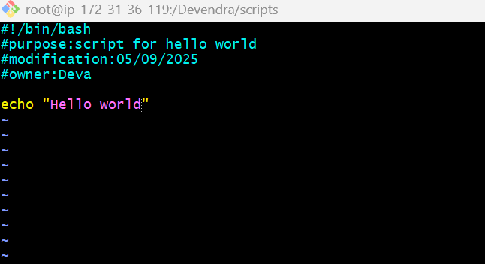

* **chmod 755 helloworld.bash -** change the permissions
* **ll –** long list
* **./helloworld.bash -** gives the output

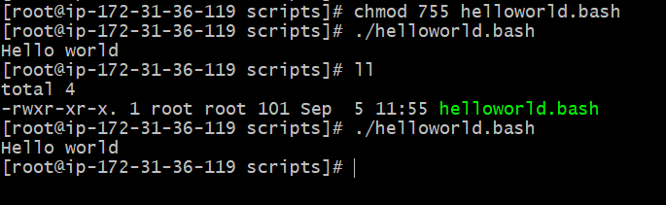

* if we want hello world in middle

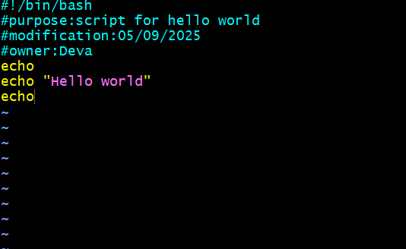

**Output:**

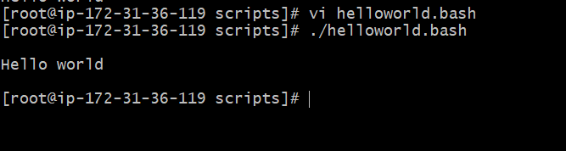

* **commands script**
* Create a script file and enter that script file **vi commands.bash**

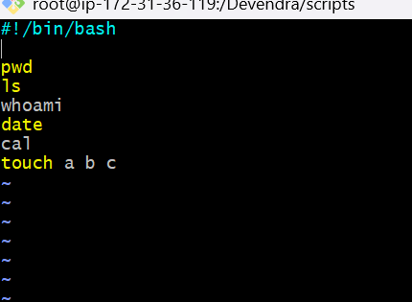

* Give permissions - **chmod 755 commanads.bash**
* **./commands.bash -** To execute the script

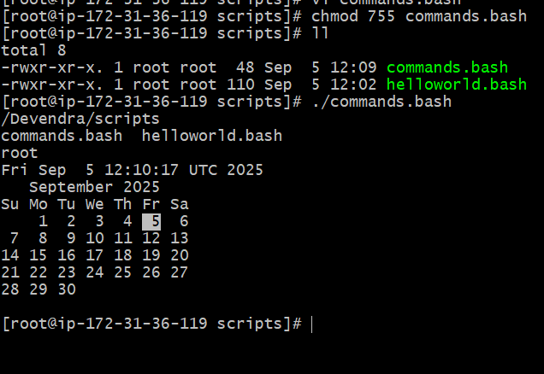

* Check one by one command ,same content is appearing or not

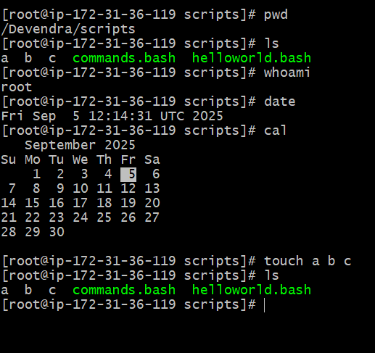

* **Basic administration task:**
* Create one script file **vi admin.bash**
* **Top | head -10 -** it gives first 10

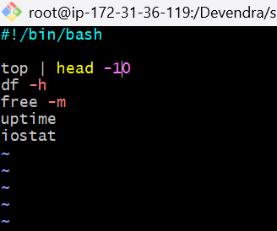

* **./admin.bash -** excute the script

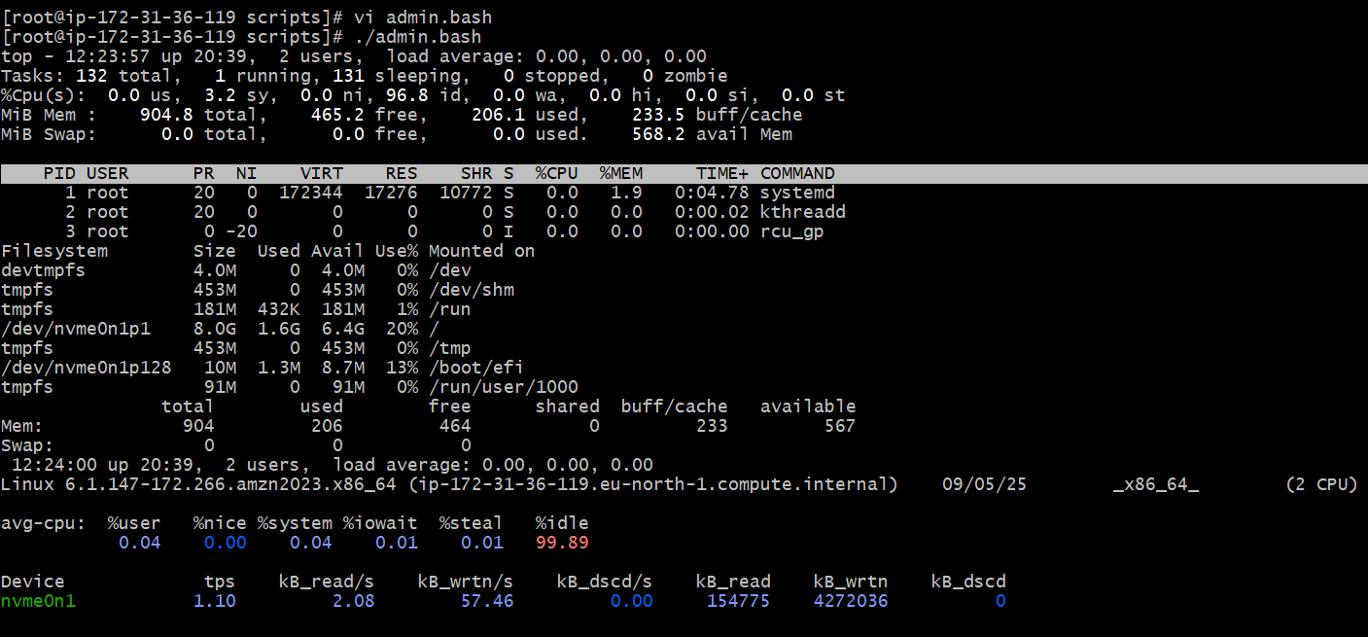

* **Defining variables:**
* **Vi variables.bash -** create one script file for variables
* **And**  write the content

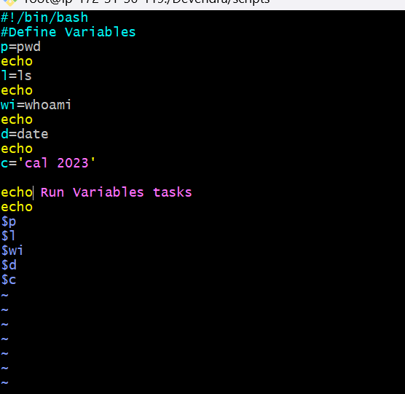

* **Chmod 755 variables.bash -** provide permissions
* **ll - long list**

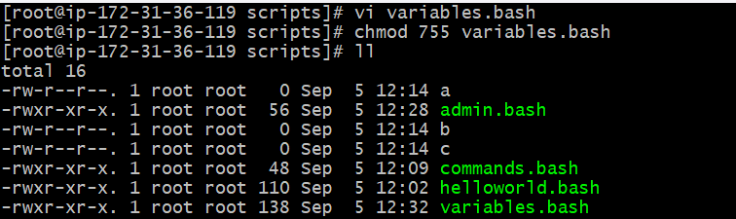

* **./variables.bash -** to execute the script

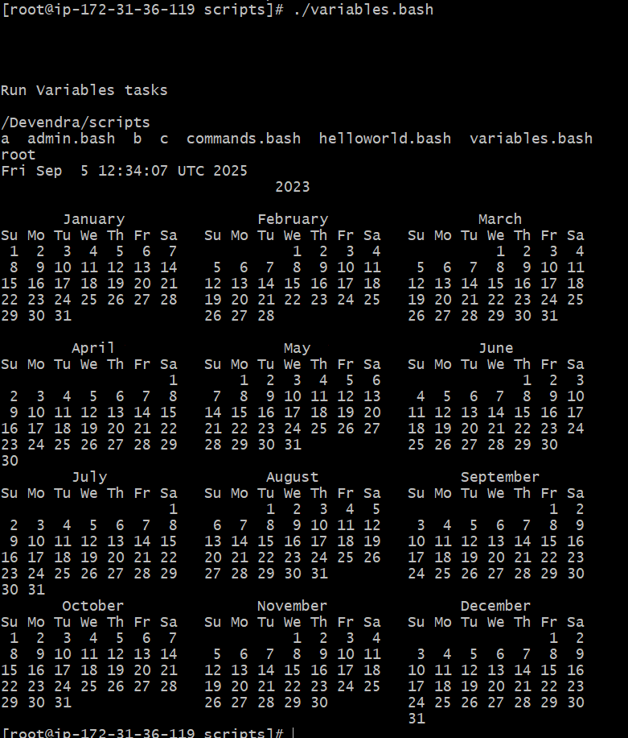

* **Cat variables.bash -** To read the content of file

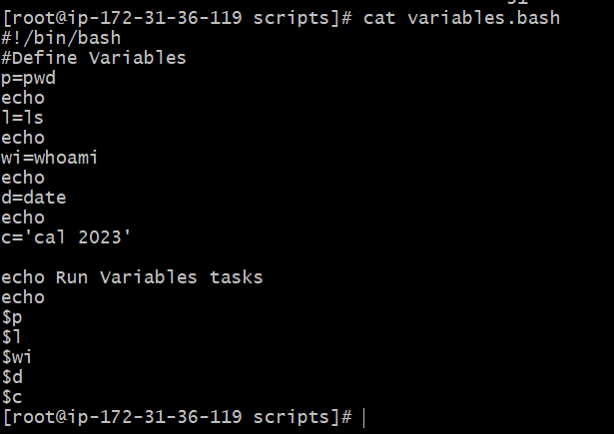

* **Input output script:**
* **Read –**To take command from user
* **echo -** To print the output
* **Vi input.bash -** To create one script file

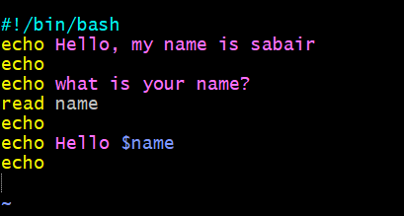

* **Chmod 755 input.bash -** provide permissions
* **ll -**  Long list

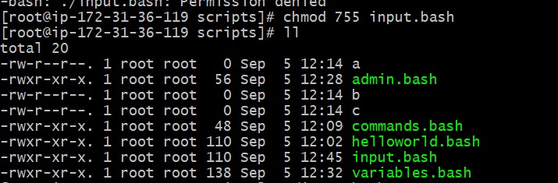

* **cat input.bash -** to read the content of file

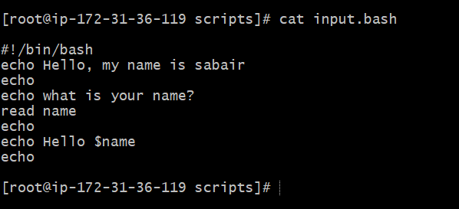

* **./input.bash -**  execute the script

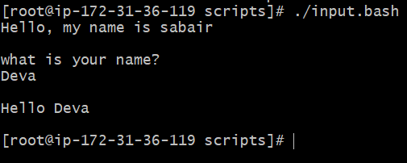

* **Vi output.bash -** Create one script file

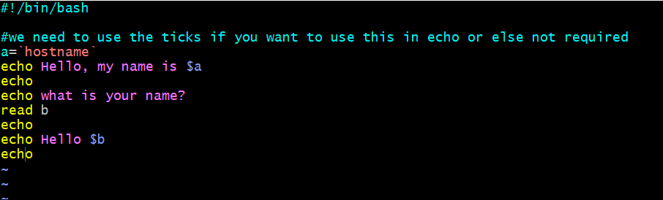

* **Chmod 755 output.bash -** provide access

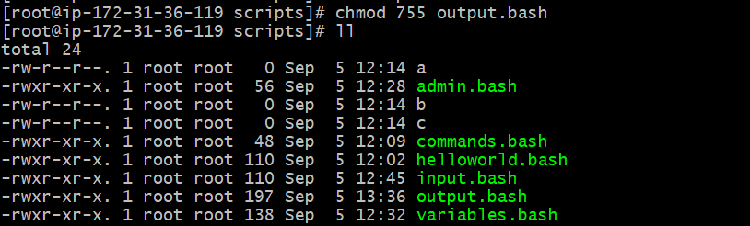

* **./output.bash -**  execute the script

